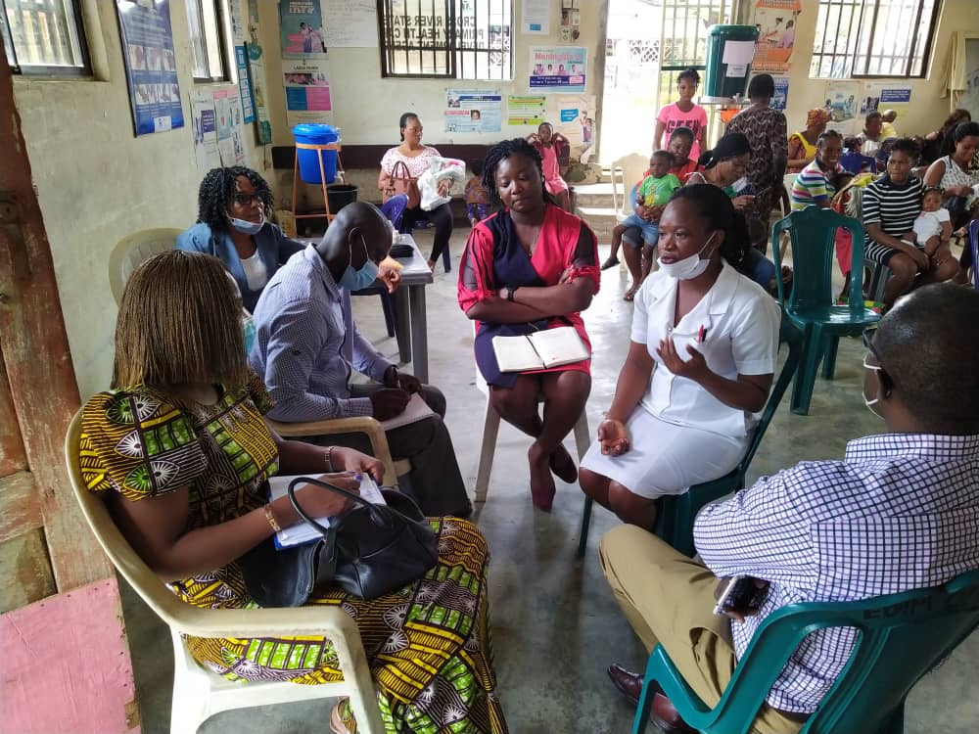
Foundation for Healthcare Innovation and Development (FHIND)
7A Otop Abasi Street, P.O Box 1636. Calabar, Cross River State, Nigeria.

ANNUAL REPORT

2021
Email: [admin@fhind.org]  Website: [fhind.org] | Tel: [ +234 8037236919]  [+234 8069216707] | 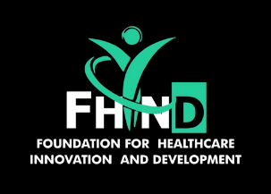

Profile
Foundation for Healthcare, Innovation and Development (FHIND) is a not-for-profit group and associates’ network which is both non-political and non-religious.

Our Mission:
To promote research, innovation and service development through the sustained improvement of health systems and services; especially for vulnerable and underserved groups.

Our Mission:
To promote research, innovation and service development through the sustained improvement of health systems and services; especially for vulnerable and underserved groups.
FHIND’s activities:
- Health systems and services research, to encourage best practice and influence policy change.
- Working in partnership with government and non-government and non-government agencies to design, plan, build, scale-up and evaluate programmes and services.
- Translating knowledge into effective tools for the improvement of health service delivery.
- Advocacy for the adoption and implementation of evidence-based health practices.
- Strengthening a productive collaboration between the public and private health sectors.
- Sharing our knowledge through scientific papers.
Maximising healthcare through research and service development.

Message from the CEO
FHIND is a not-for-profit organization involved in promoting research, innovation, and service development through the sustained improvement of health systems and services for some years.
FHIND has extensive experience in community engagement and pragmatic approaches to health system strengthening in LMICs. Individuals in the FHIND team contribute expertise in innovative approaches to advocacy, communication and social mobilisation, stakeholder engagement, digital health, infectious diseases and implementation science. FHIND has also been at the forefront of advocacy for increasing awareness on prevailing health issues and improving health outcomes of persons in Sub- Saharan Africa.
FHIND staff all have expertise in public health, implementation science and digital health; they have leveraged this experience to spearhead initiatives to strengthen the health system of Nigeria over the years, particularly at primary health care (PHC) level. Our staff have also been involved in coordinating the process of adaptation of national policies (National health Policy and National Infection Prevention and Control Policy) in Nigeria and are committed to using their extensive experience in research, stakeholder engagement and policy adaptation to drive the implementation of the vision and mission of our organisation.
At FHIND, we are open to meaningful collaborations geared toward health system strengthening and overall, improving the lives and well being of the people.
Dr. Akaninyene Otu (MBBCh, DTM&H, MPH(Leeds), MRCP(UK), FWACP)
Executive Director.
akanotu@yahoo.com

2021 Activities

FHIND was involved in several projects in 2021.

Project 1: Tackling non-communicable diseases in primary care facilities in Nigeria through clinical guidelines and m-health training strategies:

Background
Non-communicable diseases (NCDs) are estimated to cause 24% of total deaths among Nigerians, with cardiovascular diseases, cancers and diabetes accounting for 7%, 3% and 2% of proportional mortality. The World Health Organization (WHO) reports that the probability of dying prematurely from NCDs in Nigeria is as high as 20%. It is in recognition of this, that COMDIS-HSD, in collaboration with the Nigerian Government, adapted a generic NCD care package to the Nigeria context through a technical working group process facilitated by the NCD Division of the Federal Ministry of Health (FMOH) in Abuja Nigeria in 2015. The FMOH NCD care package, which was finalised in 2018 following a pilot-training in Calabar that was facilitated by FHIND, consists of a concise ‘quick reference’ NCD diagnosis and treatment deskguide; a lifestyle and health education deskguide; a treatment card; and training modules. To ensure widespread uptake of the NCD care package across Nigeria, an innovative approach is required such as electronically-delivered continuing professional development (CPD) courses.

Process
TThe FHIND team comprised of Dr Emmanuel Effa and Mrs Obiageli Onwusaka carried out the clinical supervisory visits from 24th -29th August 2020. The team visited 19 out of the 20-pilot primary health care (PHC) facilities. The trip afforded the team with the opportunity to have robust discussions with the nurses and the heads of the facilities. They also carried out clinical supervision of the NCD nurses and had discussions around COVID and its impact on the project. Each of the facilities were provided with Infection prevention and control materials (hand wash, bleach, hospital-grade disinfectant, face masks, and latex gloves).

Evidence of impact and policy engagement
Preliminary data analysis shows that there has been a consistent increase in the total number of NCD cases seen across the pilot facilities as shown in the Figure 1 below.
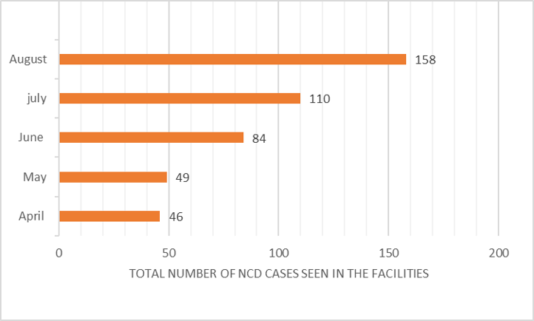
The Mobile CPD4Nigeria component of the project involved provision of a non-communicable diseases (NCDs) care package for front-line doctors in Nigeria through electronically-delivered continuing professional development (CPD) courses. This represents the pioneer use of mobile technology (phones, tablets, laptops) to provide Continuing Professional Development Courses for Medical Doctors in Nigeria. FHIND is part of a consortium that has designed and deployed the Mobile CPD4Nigeria Project. The other partners are InStrat Global Health Solutions and University of Leeds.

Electronically delivered CPD courses
Currently, medical doctors in Nigeria who are outside a training programme are required to get 20 CPD points every year to remain on the register of the Medical and Dental Council of Nigeria (MDCN). This has resulted in a proliferation of CPD awarding training programmes for doctors across the country. Doctors who attend these CPD awarding events are expected to pay an attendance fee to the organisers.
The FMOH NCD care package materials have been developed into electronic CPD course modules for doctors, particularly for General Hospital doctors, Primary Health Centre (PHC) clinicians, and clinicians in private practice.
InStrat Global Health Solutions, a health technology company in Nigeria owns a video training (VTR) Mobile Training Application that can be used on any smart phone, tablet or laptop/desktop computer, off-line or while connected to the internet. VTR Mobile supports multi-media training content including text, audio and video-based training: this platform can be used to provide NCD CPD modules based on the FMOH NCD care package materials. The modules will include video consultation material, tests and reflection notes. VTR Mobile features quizzes in between course modules such that a pass is required for proceeding to subsequent modules and at the end of courses, after which certification can be provided to successful trainees. Once users log on and download the training content, which is stored locally on the device, they can view the content as often as they want without incurring additional data costs. VTR Mobile back-end administration provides all trainees with user accounts to enable them sign on and take training courses at their convenience. VTR Mobile web-based portal provides training managers with progress reports and all use data including log in frequency, course completion; test scores; etc.

Training Content
The Mobile CPD4Nigeria offers seven modules focusing on hypertension, diabetes mellitus, epilepsy, chronic respiratory diseases (Asthma and COPD), sickle cell disease, healthy lifestyle and depression. Each module features a combination of video and PDF based teaching material. Doctors that complete each module and pass the assessment tests in the application will be issued 3 Continuing Professional Development (CPD) Credits by the Nigerian Medical Association (NMA).
The training content has been adapted from the FMOH NCD documents by University of Leeds in collaboration with the Nigerian FMOH and FHIND. The training content has been approved for award of CPD credits by National NMA and is powered by InStrat Global Health Solutions.

FMOH advocacy visit.
On the 25th of June 2021, FHIND representatives Dr.Emmanuel Effa and Dr. Oby Onwusaka paid a courtesy call/ familiarization visit to the National Co-coordinator (NC), NCD Division, Federal Ministry of Health, Abuja in the person of Dr. Oyinlola Sanni. Dr. Sanni had been appointed NC upon the retirement of the immediate past coordinator Dr. Ezeigwe. Also in attendance at the meeting was The Desk officer, Monitoring and Evaluation branch, NCD Division of the Federal Ministry of Health.
Following introductions, the FHIND team made a concise presentation to the National Coordinator on the Non-Communicable Disease project which is funded by the UK National Institute for Health Research (NIHR) Global Health Research programme (project reference 16/136/100)/ NIHR Research Unit on Health in Situations of Fragility). The team also briefed the NC on the proposed next steps for the project which included state level and national level dissemination meetings as well as plans for scale-up of the project.
Dr Sanni expressed her profound delight at the visit as well as the briefing. She also expressed a few concerns regarding the scale-up plans including funding sources and increased work-load for health workers. She stated that the task shifting and task sharing policy review process which is required for a national level scale-up had started. When complete, community health extension workers (CHEWS) and health workers at primary health care (PHC) level would be empowered to provide the NCD services embodied by the project.
The FHIND team presented the project policy brief, NCD health workers’ desk guide and treatment guide to the Ministry of Health which were received by Dr. Sanni and Mrs. Omoyele on behalf of the Minister for Health.
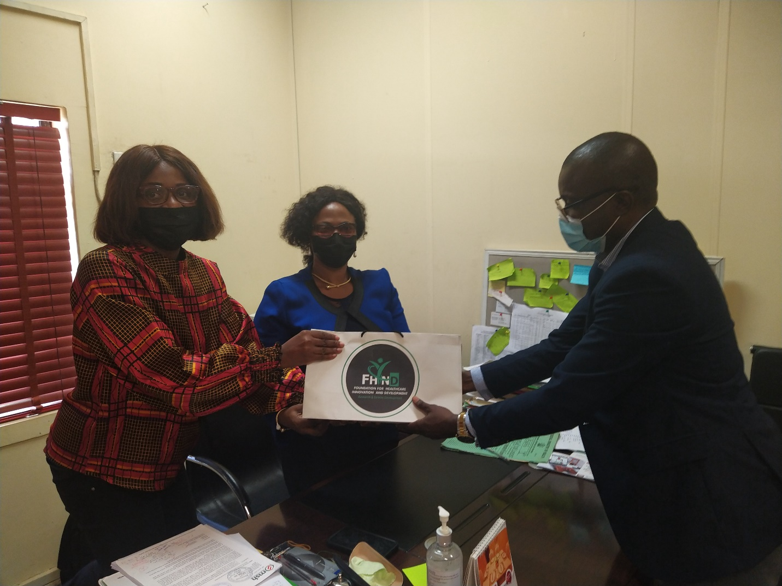
Dr. emmanuel Effa (FHIND ) presenting the policy brief and other project materias to The natiional Coordinator , NCD Division FMOH ( DR. Oyinlola sanni) and Mrs. Chiamaka Omoyele.
Photo credit : Dr. Oby Onwusaka (FHIND)

Project 2: Report of the 2021 World Hepatitis Day celebration, organized by the society for gastroenterology and hepatology in Nigeria (SOGHIN), Cross River State chapter.
Date: 28th day of July 2021

Introduction
The World Health Organization (WHO) set aside 28th day of July to raise awareness on viral hepatitis in recognition of Dr Baruch Samuel Blumberg, who discovered hepatitis B virus. The aim is to sensitize members of the public as well as draw the attention of government/stakeholders to the growing burden and rampage of viral hepatitis. The prevalence of hepatitis B and C viral infection is high in Nigeria, Cross River state inclusive with the attendant morbidity and mortality. The most recent epidemiological data showed that hepatitis B is still hyper-endemic in Nigeria with a prevalence of 8.1% while hepatitis C virus prevalence is 1.1%. The WHO posits that Africans are at a higher risk of dying of viral hepatitis than dying of AIDS, Malaria and Tuberculosis with 7 out 10 deaths from hepatitis B occurring in sub-Saharan Africa. The theme for this year is ‘Hepatitis can’t wait’ which seeks to sensitize the public on the need to stem the scourge of viral hepatitis in the midst of COVID-19 pandemic and to draw the attention of government and relevant stakeholders on the need to take decisive actions and implement sustainable health policies to eliminate the infection by 2030.

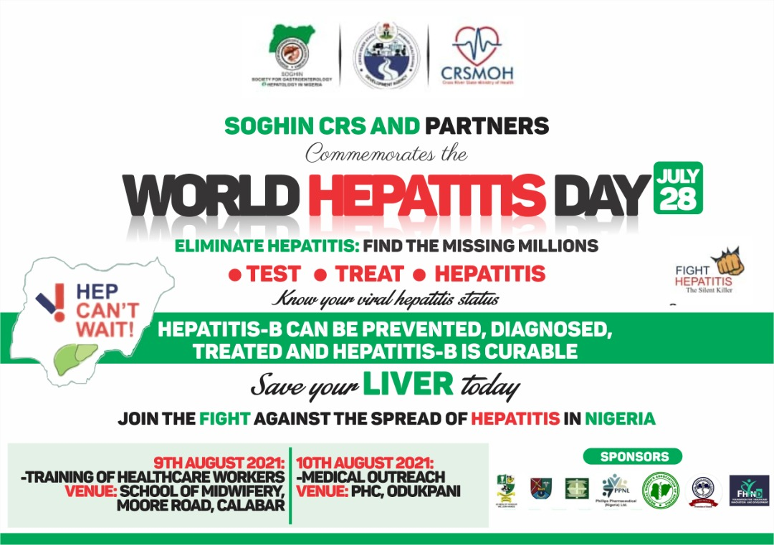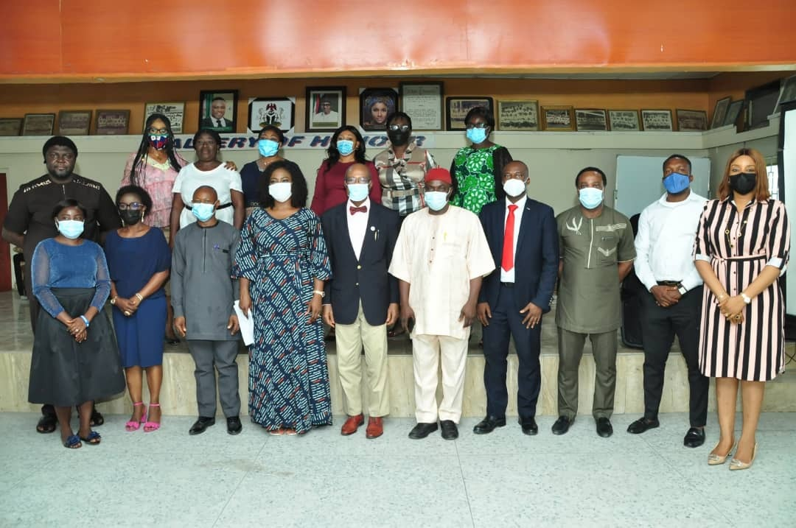

Publicity
The week-long activities started on the 28th July 2021 with a media campaign at the breakfast morning show at Cross River State Broadcasting (CRBC) television. The live program aimed to enlighten viewers on the risk factors of viral hepatitis, mode of transmission, complications, treatment as well as preventive strategies. Thereafter, we embarked upon several phone-in radio shows on CRBC radio, Hit FM , FAD FM and Sparkling FM ( from the 2-9th August 2021) to further create awareness on viral hepatitis. Through the support of Phillips pharmaceuticals and the Director General Cross River State Signage and Advertisement Agency (CRISSA) a 10ft by 20ft billboard with ‘’catchy’’ information about viral hepatitis was mounted along a busy road (Marian road) in Calabar metropolis further boosting our media campaign.

Training of Health Workers
On the 9th of August 2021, our team in Collaboration with the Primary Healthcare Development Agency (PHCDA) and the CRS Ministry of Health embarked upon a one day training of health workers in Cross River State. A total of forty-five (45) health workers comprising of Doctors, Nurses, Laboratory scientists and Community health extension workers from the 18 Local Government Areas in the state were trained. The training content included; knowledge of viral hepatitis, identification of risk factors for viral hepatitis, principles of management, complications and prevention of viral hepatitis. Resource materials and educative pamphlets were distributed to all participants. They also partook in a pre and post-test to assess their knowledge on viral hepatitis. During the opening ceremony the Director General of the PHCDA (Dr Janet Ekpenyong) described the training as being the first of its kind and subsequently nominated Hepatitis Focal Persons from each of the 18 LGAs. Other distinguished guests were the Commissioner for Health ably represented by Dr Iwara Iwara the Director Public Health, the Chairman Pharmaceutical Society of Nigeria-CRS and our amiable Chairman of SOGHIN-CRS Prof Rowland Ndoma-Egba.

Free Hepatitis B and C Screening, Vaccination and Consultation.
On Tuesday, the 10th of August, 2021 an expanded team of volunteers comprising members of SOGHIN CRS Chapter, Medical Women Association of Nigeria (MWAN) CRS, Cross River State Medical Students Association, Pharmaceutical Society of Nigeria, Cross River State Ministry of Health and the staff of the Primary Health Care Development Agency embarked on a massive (one-day) hepatitis awareness campaign at Odukpani Qua Primary Health Centre, in Odukpani LGA. The activities during the programme included; enlightenment/awareness campaign on viral hepatitis. Free hepatitis screening, free vaccination of those who tested negative to hepatitis B virus, free consultation and free abdominal ultrasound scan for those with clinical indications.
A total of one hundred and fifty-five (155) persons were screened for hepatitis B and C, four (4) tested positive to hepatitis B virus, all tested negative to hepatitis C virus. A total number of one hundred and forty (140) participants were given their first dose of HBV vaccine (with the staff of the PHCDA to follow up the administration of the remaining two doses). In addition, a liver ultrasound scan was carried out in 12 selected individuals. Free medical consultations and dispensing of essential drugs such as antimalarials, haematinics, analgesics, anti-helminthics, and antibiotics amongst others were carried out. The staff of HIT FM were also screened, and a total of 19 were tested; one (1) tested positive for hepatitis B virus and none for hepatitis C virus. All positive cases were duly counselled and referred to the Hepatitis Care centre/Registry of the Department of Internal Medicine, University of Calabar Teaching Hospital for appropriate follow-up.
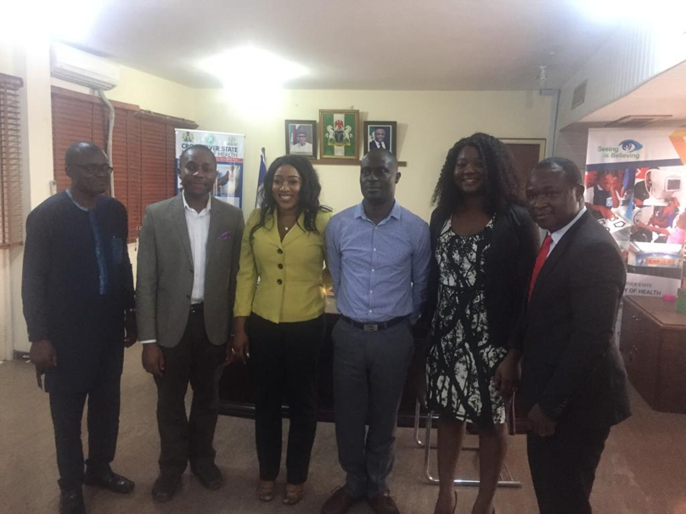
From L-R: Dr. Emmanuel Effa (FHIND), Dr Akan Otu (Executive Director, FHIND), Dr. Betta Edu (Honorable Commissioner for Health, Cross River State), Mr Lawrence Oloigidi ( FMOH, Abuja), Dr Obiageli Onwusaka (FHIND), Mr Peter Yougha (Instrat)

Project 3. Improving public awareness of sepsis in South Eastern Nigeria through innovative digital strategies
Introduction
Sepsis, a life-threatening infection related condition is a leading cause of death and disability worldwide but particularly in resource limited settings where awareness is low. These outcomes are related to chronic political, poverty, health inequity and health system challenges especially in Africa. To mitigate these poor outcomes, the implementation of evidence-based interventions such as sepsis-6 care bundle of care is necessary. This has been shown to significantly reduce mortality and morbidity. Sepsis-6 is a clinical care bundle consisting of comprised of six processes namely: blood culture, full blood count and lactate estimation, intravenous (IV) fluid challenge, IV antibiotic(s) administration, urine output monitoring and oxygen therapy.
Sepsis recognition is poor among health care workers and the management falls far short of evidence based international standards. This is linked to poor awareness. Presently, guidelines for management of patients with sepsis and critically unwell patients are lacking in Cross River State. Our Sepsis awareness project involved designing and implementing a digital health educational module on sepsis aimed at improving the knowledge of frontline medical doctors across CRS on the diagnosis and management of patients presenting with sepsis.

Implementation
We have designed and implemented an electronic educational module on sepsis for doctors and nurses in Cross River State. This was complemented by pre- and post-tests and a user satisfaction survey to enable us assess the effectiveness of the educational package and usability of the mobile health learning platform
We conducted a face-to-face training for key health workers at the University of Calabar Teaching Hospital (UCTH) to recognise and treat sepsis appropriately with emphasis on institutionalising sepsis-6 bundle of care.
We produced and distributed education, information and communication (EIC) materials on sepsis to the general population to raise awareness on sepsis and reduce the likelihood of death from sepsis in CRS. In addition, we documented the perspectives of patients with sepsis in CRS using a photo diary of impactful stories and created a map of the journey of patients with sepsis in CRS with focus on the risks and care given
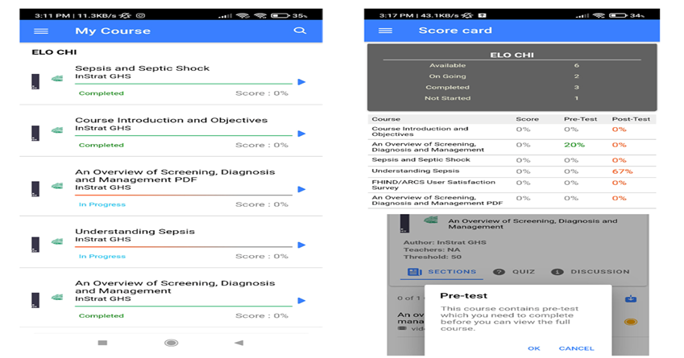
We have begun the process of collecting photodiaries to map of the journey and perspectives of patients presenting with and managed for sepsis at the to UCTH.
Impact
We have received feedback on the usefulness of the training from key participants especially in relation to the use of innovative digital platform to deliver capacity building. These have been very positive. We are in the process of sharing our findings in a scientific publication as well as engaging health managers on the implementation of more integrated sepsis prevention, recognition and timely management.
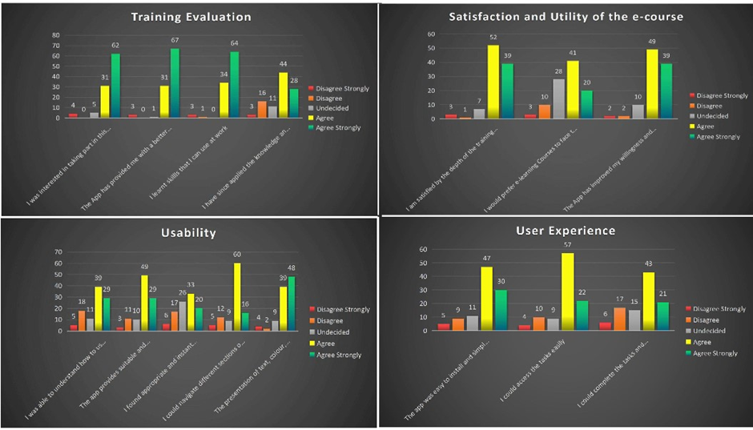
Funding: This project was funded by a small grant from the African Research Collaboration on Sepsis

